**Project Proposal**

**Team:**

1. Rudra Teja Potturi
2. Bala Gopi Krishna Sabbineni
3. Varun Goud Pulipalpula

**Name:** Teacher-Helping Application

**Problem/issue:** Lots of professors facing problems in taking attendance because of proxy attendance and times of any important events. Students facing problems with unknown schedule of classes and other activities.

**Description:** We are designing an Android Application which is used for instructors and students. This app mainly for teachers which supports adding a new student to class or a department, make any changes in class timings, calculate CGPA of all students individually etc. There are mainly four activities. Profile activity which is used to check the student data and also for editing the existing student data and adding a new student data. Secondly, Attendance activity is for taking the attendance and storing in the database. Last, but one is Timetable activity which is basically used to set an event so that all the students can view it and attend that event on time. Finally, CGPA activity which is used to calculate the GPA of the students based on their grades. A database is used to store the data of all these activities.

**Data Required:** Details of the students like name, roll number, phone number is collected while registration of a student and are stored in a cloud database. Details of the professors, schedule, subjects are collected and are stored in the cloud database.

**List of Activities:**

1. **Profile**
2. **Attendance**
3. **Timetable**
4. **CGPA**

**Note:** Number of activities may increase while implementing the project.

**Rough Activities:**

Home page:

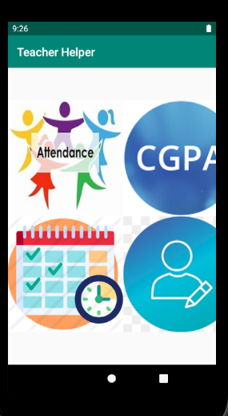

Attendance Page:

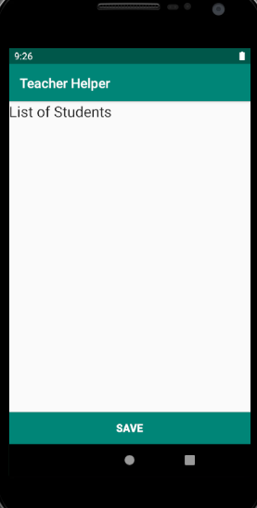

CGPA page:

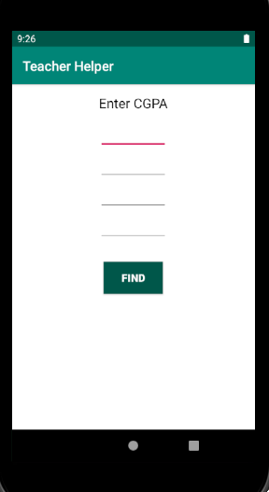

Timetable page:

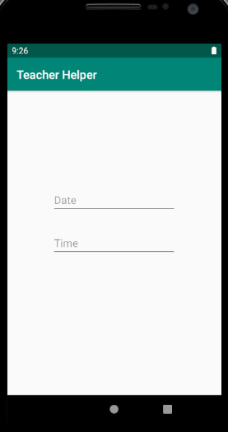

Profile page:

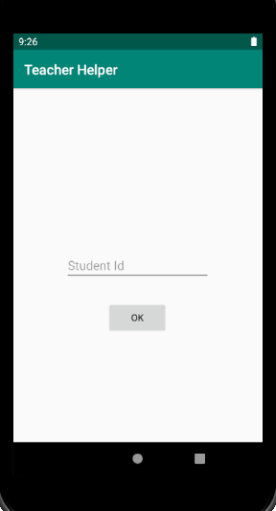

**Risks:**

* We are not using any outside API.
* As we are working in the group of 3 there may occur some merge conflicts.

**Required functionalities:** Database

**GitHub link:** <https://github.com/RudraPotturi/teacher-helping-application>